THE BESB BUZZ….

A Newsletter for Families of Children who are Blind or Visually Impaired

Volume 20 Spring 2018

Published by the State of Connecticut

Department of Rehabilitation Services (DORS)
Bureau of Education and Services for the Blind (BESB)

Feature Articles:
A Day at the Slopes, CT NAPVI and NEC, Preschool Staff Test New APH Product, Space Camp, Rock Climb Fairfield, Community Service, Fire Is So Loud, Prison Braille Program, Let’s Get Moving

In an effort to provide you with faster delivery of our newsletter and program flyers, save paper, and contain printing costs, we are now posting an expanded electronic version on our website: www.ct.gov/besb.
(Newsletter is also available in Spanish on our website)
If you provide us with your e-mail address, we will send a copy of the newsletter directly to you by e-mail. Please give your preferred e-mail address to your child’s TVI.

Feel free to contact the newsletter’s co-editors with any suggestions at
lisa.pruner@ct.gov or tina.gutierrez@ct.gov
We welcome your comments and ideas for future newsletter topics.
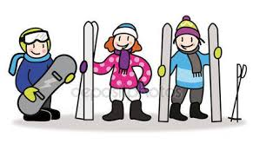
A Day at the Slopes: BESB Takes Students to Ski Sundown
By Alaya Conaway

NEW HARTFORD, CT — Snow-covered hills, icy streets, and a chill breeze in the air - it was a perfect day for a trip to the ski slopes.

On Saturday, February 3, the Bureau of Education and Services for the Blind (BESB) took students to Ski Sundown. Participants had the opportunity to ski and snowboard, along with time to catch up with friends. Lessons were provided for first-time skiers.

The trip is done annually, providing students with a fun activity to do in the chilly winter.

Ski Sundown is one of Connecticut’s most popular ski areas. Located in northwestern New Hartford, it attracts skiers of all ages and is one of the state’s most popular winter attractions.

At the end of their runs, skiers warmed up with hot chocolate and cookies. All in all, memories were made and everyone had a good time.

If you missed this program and would like information about scheduling your own adaptive ski or snowboard lessons, call the welcome center at Ski Sundown- (860) 379-7669 or visit: http://www.skisundown.com/Lessons-Packages/Lessons-Packages/Private-Lessons-Packages/Adaptive-Lessons.

CT NAPVI Parent Group with NEC

Just a reminder that CT NAPVI (National Association for Parents of Children with Visual Impairments) and NEC (New England Consortium for DeafBlind Technical Assistance and Training) joined forces and offered two wonderful family outings this school year. In October, the groups sponsored an apple picking outing and in March, a trip to the CT Science Museum.
Consider joining in the fun!

Contact Shanda Easley for information on CT NAPVI at: NAPVICT@gmail.com

For additional information about registering your student who may have both a hearing and vision impairment with NEC, please visit: http://www.nec4db.org/

Preschool Staff Field Tests New APH Product

Preschool teachers have been hard at work field testing a new math product being developed by American Printing House for the Blind (APH). Five Little Speckled Frogs is a story book with props and activities designed for teaching emergent numeracy. Four preschool TVIs at BESB were selected to participate in field testing this new product which should be available to students within the next year.

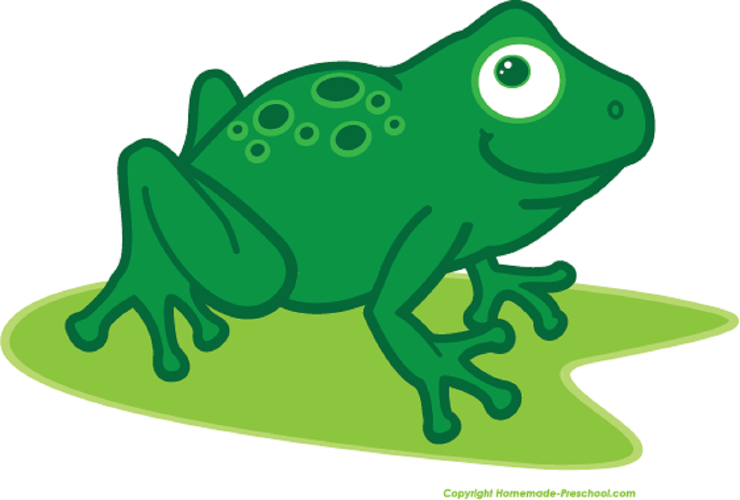

Preschool Staff Field Tests New APH Product

Preschool teachers have been hard at work field testing a new math product being developed by American Printing House for the Blind (APH). Five Little Speckled Frogs is a story book with props and activities designed for teaching emergent numeracy. Four preschool TVIs at BESB were selected to participate in field testing this new product, which should be available to students within the next year.

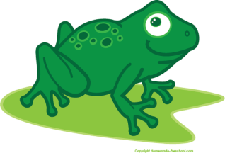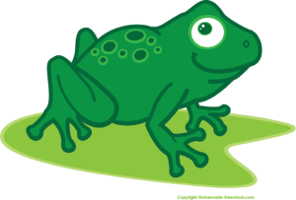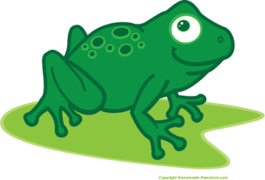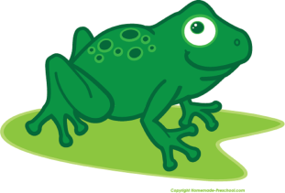

My Experience at Space Camp
By Lizzy Cappelli
This past fall I had an extraordinary opportunity. I was able to attend Space Camp for Interested Visually Impaired Students (SCIVIS) at the U.S Space and Rocket Center in Huntsville, Alabama. While I was there I experienced so much and accomplished more than I thought possible. The week was designed for students with vision impairments so everything was accessible with large print and Braille. Mentors understood that you couldn't see, but that you still had a courageous vision. Everyone used a white cane, so I was not alone.

During my week at Space Camp I was able to try out simulations of the International Space Station (ISS), mission control, and an orbiter. For our first mission I was in the ISS where I worked as flight engineer and completed checklists based upon our flight plan. During our second mission I communicated with the ISS as Pay Com. My job was to assist the ISS when they experienced anomalies by using a manual that contained checklists on how to fix the anomalies.

As the week progressed I became very close to my team. This was very important because we needed to trust each other during activities such as the zip line. For the zip line we traveled to Area 51, the outdoor ropes course. To reach the zip line we had to climb a 45 ft tower. When we reached the top of the tower we unclipped the safety ropes and put on the zip line ropes. We sat on the edge of the square platform and pushed off. The zip line stretched from the tower to another pole about 100 feet away. We soared through the air to the pole and then momentum brought us halfway back to where a worker grabbed our feet and lowered us to a ladder which was held up by our teammates.

On another day we climbed the Pamper Pole, which is a 32 ft wood telephone pole with a metal ladder leading to a two-foot circular wood disk. We put on harnesses and climbed the ladder while our teammates kept tension on the ropes holding us up. I was able to climb the pole quickly, but when I reached the top it was scary trying to place both my feet on this two-foot disk that wobbled back and forth. But I did it. I stood up with the encouragement of my teammates and chaperones. It was an exhilarating moment. At the top of pole you had to rotate 90 degrees by carefully shuffling your feet. Then on the count of three, you jumped off. This was the strangest part because you didn’t fall you just hung in space for a minute until your teammates lowered you slowly to the ground.

In addition to some magnificent outdoor experiences, we also experienced gravity of the moon and zero gravity. The moon's gravity was simulated using the 1/6 chair, so named because there is only 1/6 of gravity on the moon compared to Earth. To experience zero gravity we were able to SCUBA dive, which was my favorite part of the week. I put on an oxygen tank and SCUBA mask and climbed down a ladder into a 24 ft tank with an amazing instructor by my side. At the bottom of the tank, I walked around and climbed on a jungle gym on the bottom of the tank. In addition to the jungle gym, there was a bowling ball which my instructor showed me how to spin on my finger. We had to resurface five minutes after reaching the bottom since we only had a certain amount of oxygen, According to my crew trainer, I had the largest smile on my face when I resurfaced. She was right; I still remember how that smile felt.

During the week at Space Camp we saw mock-ups of rockets that were created to show their actual sizes and heard the stories behind NASA's programs. We learned that American astronauts must speak Russian to travel to the ISS. We heard from people with vision impairments who work at NASA and we learned how water is produced in the ISS.

One of my favorite nights was astronomy night. We visited tables which had information on the sun, stars and new technology. At the sun table I tactually felt prominences, sun flares, and sunspots. This was really cool because we learned about these exact phenomena last year in science, but I never fully understood them until then. At the star table I felt a Braille star chart, and it was amazing to feel constellations. I have always believed constellations are beautiful to see, shimmering in the dark sky, but never knew what they looked like.

I am so proud of my accomplishments at Space Camp and all the new
information I gained.

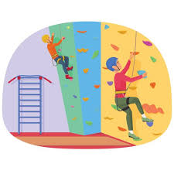
Rock Climb Fairfield
By Michele Margenau
On November 7, BESB held an event at Rock Climb Fairfield in which 10 middle and high school students participated. While a few of the students had previous rock climbing experience, many experienced it for the first time. Rock Climb Fairfield did a great job supporting our students. One staff member expressed that this was the best group of the week! A parent who watched the event felt immense pride in her child’s accomplishment.
This event also provided the opportunity to work on several areas of the Expanded Core Curriculum:
- Recreation & Leisure: Rock climbing is increasing in popularity and will be a new sport in the 2020 Olympics. Fairfield Rock Climb offers after school climbing and team opportunities if any student is interested.
- Self- Determination: Students pushed themselves to step out of their comfort zones and worked hard to reach the top of the wall.
- Social Interaction Skills: Students engaged both staff and peers to achieve their climbing goals while cheering each other on.
- Orientation and Mobility: Students practiced cane travel and sighted guide in a novel environment. They also experienced the sensation of their bodies being suspended and hanging in space.
Many of the students expressed a desire to participate in this type of event again. While I imagine many of the students were sore the next day, it was a great event enjoyed by all!

Links for

Community Service
Community Service
By Adrienne Brown and Amy Flores

In the fall of 2016, Jomar was a high school junior, a braille reader and new to the United States. Before arriving here, only 1 Perkins brailler was available at his school for the blind and he was discouraged from using it-lest he get lazy. Therefore, he was lightning fast on his full page slate and stylus. He’d been practicing English for a few years but never had to rely on it until his arrival in the United States.
At the middle school across the street was another student who was familiar with a brailler, 6th grader Anthony.
When the guidance team was reviewing graduation requirements for Jomar they decided to get creative with community service. A special educator who knew both students suggested, “Maybe Jomar could mentor Anthony?” TVIs Mike and Amy helped to facilitate the connection.
Last school year Jomar and Anthony got together with their TVIs every other month for some cooking opportunities and to talk about their technology. Jomar’s international experience also led to conversations about cultural norms.
This year the fun has continued with TVIs Amy and Adrienne. Jomar was able to attend a summer class at the Carroll Center in MA and his cooking skills have taken off. Jomar and Anthony branched out to baking. Can anything beat a warm chocolate chip cookie straight out of the oven? Jomar effortlessly talks Anthony through baking skills, including how to use an ice cream scoop to get cookie dough from the container and onto the cookie sheet.
Both students starred with solos in their schools’ holiday concerts and then performed together for their TVIs. Together they continue to explore iPhone technology and to bake delicious treats. What began as a way to complete “community service” hours has turned into fun and friendship. Their connection is real and genuine.

By Adrienne Brown and Amy Flores

In the fall of 2016, Mike Pompano was assigned a new student to his caseload. The student was high school Junior who was a braille reader. He was new to the United States. He’d had one Perkins Brailler in his whole school (for the blind) which he was discouraged from using—lest he get, “lazy”. He was lightning fast on his full page slate and stylus. He’d been practicing English for a few years but never had to rely on it until his arrival.
Enter Jomar.
Across the street from Jomar’s high school is the middle school for the town. At the middle school is another student who is familiar with a brailler.
6th grader Anthony.
When the guidance team was looking at graduation requirements for Jomar they decided to get creative with community service. A special educator who was on the teams of both students suggested, “Maybe Jomar could mentor Anthony?”
Mike and I were able to find some time last year (about one meeting every two months) for Jomar and Anthony to get together to have some cooking opportunities (including one ‘side by side’ taste test where one student used the microwave while the other used the stove) and talk about their technology. Jomar’s international experience led to conversations about cultural norms.
This year, the fun has continued with Adrienne Brown taking over for Mike Pompano. Jomar was able to attend an experience at the Carroll Center over the summer and his cooking skills have taken off. We’ve branched out to baking (can anything beat a warm chocolate chip cookie minutes after it comes out of the oven?) and the iPhone. Jomar effortlessly talks Anthony through the steps to execute cooking skills, such as verbalizing how to place the ice cream scoop to get the dough out of the container and onto the cookie sheet. Both students starred in their schools Holiday Concerts with solos. Though Adrienne and I had tried for weeks to get a preview of the solos, it finally happened when the two were together.

Fire Is So Loud! Addressing Empty Language in Children with Visual Impairments
By Peg Palmer

Children who have CVI or other visual impairments have a much greater chance of developing “empty language” than their sighted peers; that is, vocabularies that are not rooted in meaning. “Empty language refers to a situation of confusion where the blind or visually impaired child has words to talk about something, but incorrect or no ideas to attach to the words.” (Anne McComiskey, Family Connect, American Foundation for the Blind.) With less visual input, reduced shared visual attention, and fewer chances to interact with their environment, they may have poorer vocabularies and use “empty words.” Consider this story to illustrate empty (or incorrect) language:

Carlos is a four year old, who has been blind from birth. He attends a preschool program located within a public school building and fire drills are a common occurrence. The shrieking siren is extremely loud. Carlos’s team tells me he absolutely hates fire drills, covers his ears and cries throughout them. They have a hard time calming him down afterward.
One day, I was visiting him on a fire drill day. I tried to prepare Carlos in advance, by talking to him about it and warning him that one was coming soon. It did not help. He covered his ears, burst into tears and was inconsolable for some time after it was over.
When he calmed down a bit, and I could talk with him, I asked him about the fire drill, hoping to get him to express his thoughts and feelings. “I HATE fire!” he told me, through jagged breaths.
Then, it struck me. Empty language?
I asked him, “Carlos, what is fire?”
He put his hands to his ears and told me “Fire is so loud.”

Carlos had assumed that the siren sound itself was “fire.” Due to his vision loss, he had no direct experience with fire and had assumed (with good reason) that fire was the obnoxious sound. Think about it from his perspective: every time that loud noise came blaring through the school speakers, the word he always heard associated with it was “fire.”
Sadly, I did not have any magic strategies to help him cope with the drills, but we could at least help him learn the difference between fire and the fire drill siren.
With empty language, children can frequently ‘talk a good game.’ Telling us that he hated fire sounded perfectly reasonable from a four year old perspective. But it was only though probing his thinking that we could discern his “empty” or incorrect language. In children with CVI, empty language is also common. They may look at images or scenes but not be able to make sense of what they see. Meanwhile they hear language swirling around them. When the two don’t connect, the situation is ripe for the development of empty language.

What can we do to prevent empty language?
- Name the item that the child is looking at – keep it simple at first! “Cat, you see the kitty cat!”
- Repetition is how all children learn language. Children with vision impairment need repetition as well, probably even more, due to processing delays and lack of experience. An adult may feel they repeat things millions of times, but it is not wasted effort.
- Story time: Too often, children with CVI are plopped down to listen to stories in preschool programs, while their sighted peers have the benefit of seeing the pictures. We are doing a double disservice to these young children if we do not make the pictures accessible and available to them. But how?
- Bring one or two of the central themes to the child. For example, for a book about a little girl and a pumpkin, bring a real pumpkin and a life like doll to the child. Support as they explore the objects with hands and eyes as the story is read.
- Use an iPad. For children who are able to process pictures, take pictures of the book’s contents before the story is read. Show the child the pictures using back lighting and zoom in to reduce visual complexity.
- If the pictures from the book are too complex, showing these to a child who cannot process them is not helpful. If the story is about a cow, and the child has shown the ability to understand simple clear photographs, call up a simple photo of a cow and use that instead of the pictures from the book.
New Prison Braille Program

In September of 2017 The American Printing House for the Blind (APH) was awarded a $26,000 grant from The J. Walton Bissell Foundation in CT on behalf of DORS/BESB and The Dept. of Corrections. A new Braille Transcription Program has been funded at York Correctional Center in Niantic as a result of this grant.

Nancy Mothersele, BESB Braille Coordinator, collaborated with APH, The National Prison Braille Network, The Bissell Foundation, DORS/BESB Commissioner Porter, Commissioner Semple of the Department of Corrections, the Prison Industries program and the Warden of the York Women's Correctional Facility to discuss building a prison Braille program at York.

Nancy will supervise the training of 10 participants who will become certified in Unified English Braille and eventually Nemeth Code. These participants will be learning a highly specialized skill to use upon release while supporting Connecticut students who read Braille.

Nancy, BESB, and the Corrections Dept. are looking forward to this close partnership in building a successful program that will support positive outcomes for both inmates and students.

SAVE THE DATE
The Fall 2018 MIVI-DB Introductory Workshop, Teaching
Students Who Are Visually Impaired with Multiple Disabilities Including Deafblindness, will be held AT NO COST on the following dates:
Wed 9/26/18: Paraprofessionals; Thurs 9/27/18: Families, Special Educators, TVIs, THIs, Therapists & Administrators. Your TVI will share the Eventbrite Registration Info when it goes live. Questions? Contact: Tina.Gutierrrez@ct.gov
Let’s Get Moving!
By Kendra Jenness
Incorporating Orientation and Mobility skills at home
may seem like a daunting task…..But it’s as easy as 1, 2, 3!

- Encourage Independent Movement and Exploration
- Encourage your child to reach toward interesting sounds and toys by purposefully placing a toy with a preferred sound within your child’s reach. Begin by placing the toy so that it is physically touching your child. Allow your child time to become aware of the toy and then to explore it before moving it a little further away. Show your excitement when a toy is found! Celebrate!
- Go for a walk around your neighborhood. How many mailboxes can your child find? How tall is your mailbox? Where does the mail go? Your walk becomes a scavenger hunt! Can you find 5 mailboxes and 2 street signs?
- Go for a walk through the grocery store. What kind of smells can you smell? Listen, can you hear the cash registers at the front of the store? Allow your child to lead the way toward the sound of the automatic doors when leaving.
2. Emphasize Body Part Recognition and Awareness
- Do Yoga! Yoga is a fantastic activity that teaches children body part recognition from the very simple to the complex, emphasizes both body and spatial awareness, AND teaches prepositional concepts such as under, over, and around.
3. Help to Develop Listening Skills
- Play “I Listen,” an adaptation of I Spy where family members can take turns describing sounds they hear. One family member describes a sound. The rest of the family tries to point in the correct direction of the sound while keeping their eyes closed.
- Stand at the end of your driveway. Ask your child to tell you when a car is passing. Stay quiet as your child listens. From what direction is the car coming? Be a detective – is the car going TOO FAST?

Remember to Have Fun!

Department of Rehabilitation Services FREE MATTER
Bureau of Education & Services FOR THE BLIND
for the Blind (BESB)
184 Windsor Avenue
Windsor, CT 06095

DATE SENSITIVE MATERIAL

DORS/BESB FALL NEWSLETTER

