THE BESB BUZZ…. Illustration of a bee carrying a letter

A Newsletter for Families of Children who are Blind or Visually Impaired

Volume 18  Spring 2017

Published by the State of Connecticut

Department of Rehabilitation Services (DORS)

Bureau of Education and Services for the Blind (BESB

Feature Articles:

Look Who’s New, Early Connections Conference, Leading the Way,

SAC is Back, Web Resources for Parents, Recent Field Trips, Upcoming Programs

In an effort to provide you with faster delivery of our newsletter and program flyers, save paper, and contain printing costs, we are now posting an expanded electronic version on our website: [www.ct.gov/besb](http://www.ct.gov/besb).

(Newsletter is also available in Spanish on our website)

If you provide us with your e-mail address, we will send a copy of the newsletter directly to you by e-mail. Please give your preferred e-mail address to your child’s TVI or contact the newsletter’s co-editors, [lisa.pruner@ct.gov or](mailto:lisa.pruner@ct.gov%20or) [tina.gutierrez@ct.gov](mailto:tina.gutierrez@ct.gov)

We welcome your comments and ideas for future newsletter topics.

Look Who’s New!

Adrienne Brown joined BESB as a Teacher of the Visually Impaired this past January. With a background in art education, her most formative teaching experience occurred while working for an arts organization that served adults with disabilities. Adrienne taught art, yoga, and poetry to her students – and was particularly interested in understanding the unique methods through which her students expressed themselves. A notable experience with a student who is blind led Adrienne to apply to the UMass Boston graduate program in Vision Studies.

Adrienne enjoys hiking, baking, and visits to New York City for museums and great restaurants. She looks forward to sharing some of her hobbies with her BESB students.

**********************************************************************************

*2017 New England Early Connections Conference*

For families of young children with visual impairments – ages birth to seven years

Saturday, April 29th from 8:30-3:00 at Perkins School for the Blind in Watertown, MA.

Cost: $35.00 which includes childcare and lunch.

Topics Include: Orientation and Mobility, Parenting Strategies, Marriage and Relationships, Sibling Panel, Mindfulness and Meditation, Recreation and

Leisure, Preschool Transitions and Quality Program Indicators, Cortical Visual Impairment, Concept Development, Literacy

Register online: [www.Perkins.org/EarlyCC](http://www.Perkins.org/EarlyCC)

Parent Education Program

SAC is Back!

By Patty Leonard and Dave Ferland

The Student Advisory Council (SAC), a group for middle and high schoolers focusing on the Expanded Core Curriculum and transition activities, has returned! We have had three events so far this school year.

The first event was held in October and included a walk through the busy streets of West Hartford with the guidance of BESB’s trained Orientation and Mobility instructors and TVI’s. The students had the opportunity to walk to a local pizza restaurant. Some of our student’s crossed busy intersections for the first time.

Over December break the group went bowling, then out to lunch. At lunch we were joined by a recent high school graduate who spoke to the group about the issues he faces in college and the responsibility associated with having a guide dog. He also discussed his use of the iPhone and voiceover. Following lunch, the students traveled to Target to make purchases and practice money skills.

In March the group went to the Metro North train station in West Haven for an overview of train travel in Connecticut. Instruction was provided in orientation and mobility on a station platform, learning the gap, purchasing tickets and using apps to read the train schedule. The students then traveled by train to Fairfield where they explored the town and ate lunch. It was a freezing cold day but we had a good adventure and learning experience.

Our next SAC event is scheduled for April 10th when students will travel on the CT Fast Track bus from Hartford to CCSU. At CCSU the students will tour the campus and eat lunch in the cafeteria.

For more information on SAC, contact Amy Flores at [Amy.Flores@ct.gov](mailto:%20Amy.Flores@ct.gov)



Leading the Way: A Connecticut Student Takes on the Grand Canyon

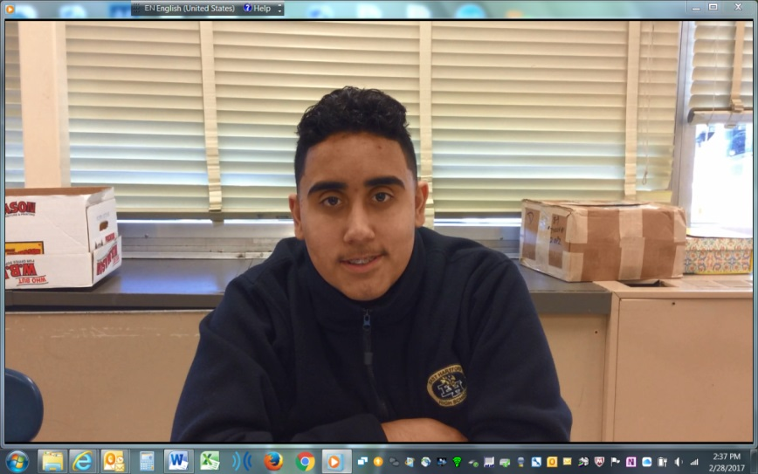

An Interview with Anthony Ortiz regarding his Leading the Way experience

Q: Good morning, Anthony. Last summer you had an interesting experience with an organization called No Barriers. Can you tell me a little bit about them?

A: No Barriers is a program that helps students face their fears and experience challenges. It helps (us) be stronger and more independent as a person. Both visual and visually impaired teens participate from all over the country. The staff show the visually impaired students ways to do all the same things as the typically sighted students. No Barriers also has a warriors program for veterans who have been wounded.

Q: How did you get involved with the organization?

A: I learned about it from my teacher of the visually impaired, Mrs. Horter. At the time, I was losing my vision. Mrs. Horter made me read articles about people who achieved cool things in spite of their vision impairments. One article was about a guy named Trevor Thomas who hiked the Appalachian Trail after losing his vision. Mrs. Horter wanted me to see I could overcome these same challenges. So when she heard about Leading the Way, she encouraged me to apply.

Q: So, your Leading the Way experience (expedition) was in the Grand Canyon. Tell me some of the highlights of your trip?

A: One of my favorite highlights of the trip was rafting through the rapids and seeing the waterfalls. I got to know a lot of people. Most of them were visually impaired. I learned that I like the outdoors a lot and overcame my fear of heights (for the most part).

Q: How do you feel the experience changed you?

A: The experience taught me that the environment is much more important than many people think it is and we should take care of it. It was also the first time I flew on a plane without my parents. I was nervous not having anyone with me, but on the way back I wasn’t as scared. After all, I had rafted the river and hiked miles up the Grand Canyon. I wasn’t as afraid!

Q: Would you encourage others to go? Why or why not?

A: Yes, I would encourage others to go to get to know how important the environment is and to overcome their fears through the challenges of the program. I also recommend it because it was super fun!

Q: If someone is interested, how can s/he get more information?

A: Leading the Way goes to many different parts of the world. The Grand Canyon and Peru are two of the destinations. If a student is interested in learning more, s/he can get information from the No Barriers website at:

<http://www.nobarriersusa.org/youth/>

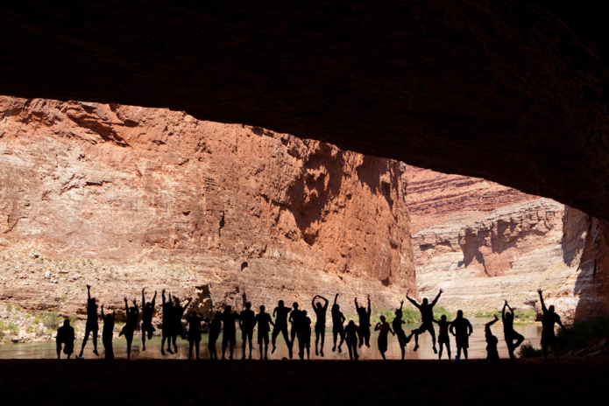 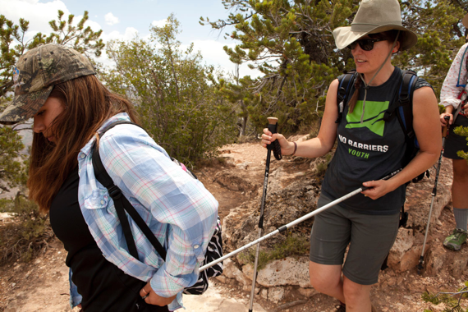

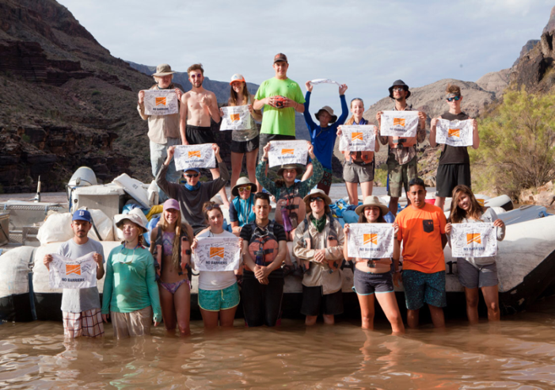 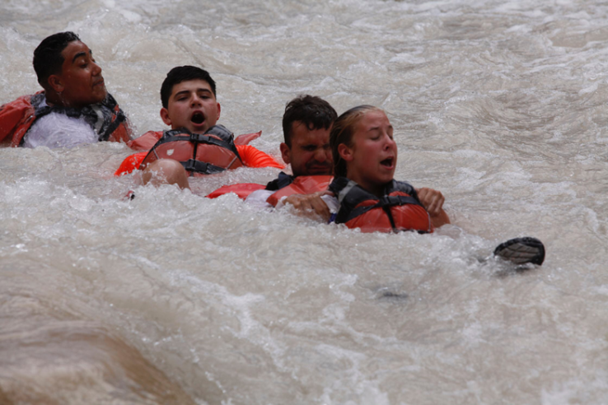

Web Resources for Parents

by Jessie Mabry, Children’s Services Technologist

Both new and veteran parents can benefit from networking, information, and mentorship, especially when raising a child who is blind or has low vision. This annotated list of websites might provide a good start:

<http://www.wonderbaby.org>

WonderBaby.org is dedicated to helping parents of young children with visual impairments as well as children with multiple disabilities. Here you'll find a database of articles written by parents who want to share with others what they've learned about playing with and teaching a child who is blind, as well as links to meaningful resources and ways to connect with other families.

<http://www.pathstoliteracy.org>

The information on this site includes parent and educator written articles on literacy topics from infancy to adulthood. Readers are encouraged to add ideas and questions, so that this will be an interactive hub of resources.

<http://www.abilitypath.org>

AbilityPath serves as a forum for education and support through blogs, events, news articles, and interest groups, allowing parents of children with special needs to connect, share insights, and learn from others’ experience. Professionals offer practical tips on topics ranging from dealing with developmental delays to read-aloud book suggestions to strategies for encouraging social skills. Many sections of the site are available in Spanish and English.

<http://nopbc.org>

Founded in 1983, the National Organization of Parents of Blind Children is a membership organization of parents and friends of blind children reaching out to each other to give vital support, encouragement, and information. There are over 3,000 members in all 50 states and divisions or parent contacts in about 30 states plus Puerto Rico.

<https://www.actionfund.org/future-reflections>

Future Reflections is a magazine for parents and teachers of children who are blind that covers topics from birth through college. Each issue provides resources and information for parents and teachers, as well as a positive philosophy about blindness. Topics range from teaching blind infants to explore their surroundings to college accessibility issues and offer answers to many of the common questions asked by parents and provide solutions to common problems.

<http://www.familyconnect.org>

FamilyConnect is a website created by the American Foundation for the Blind (AFB) and the National Association for Parents of Children with Visual Impairments (NAPVI) to give parents of children with visual impairments a place to support each other, share stories and concerns, and find resources on raising their children from birth to adulthood. The site includes articles, message boards, blogs, a calendar of events customizable by state, news and more. The entire site is available in Spanish and English.

Out and About with Children’s Services



Ski Sundown

On February 4, we offered a trip to Ski Sundown in New Hartford, CT. It was a beautiful sunny day on the slopes and the kids had a great time skiing with their adaptive ski instructors. We had 9 students participate and they ranged in age from 5 to 17. STRIDE Adaptive Sports was terrific in working with our students at their various skill levels.

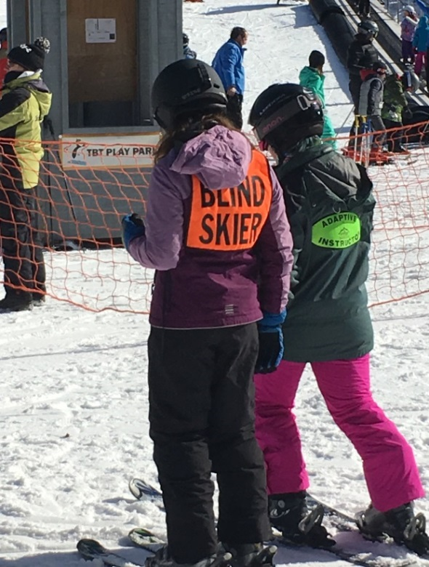

A student enjoying the Ski Sundown trip

NEC Families Visit the CT Science Center

On February 25, the New England Consortium (NEC) hosted an event for children who are deafblind and their families at the Connecticut Science Center in Hartford. Three BESB families, as well as NEC and BESB staff explored many exciting hands-on exhibits including, “Exploring Space,” “Forces in Motion,” “KidSpace” and “Engineering.

The New England Consortium for Deafblind Technical Assistance and Training (NEC) is a federally funded grant serving the New England states, through the United States Department of Education. Their purpose is to assist state and local education agencies in developing the capacity to serve children and youth who are deafblind. TVIs Mary Quinn (Special Services) and Yvonne Locke (Preschool) work closely with the staff at NEC and serve as the contact personnel at BESB. For more information about NEC, visit their website, [www.nec4db.org](http://www.nec4db.org).

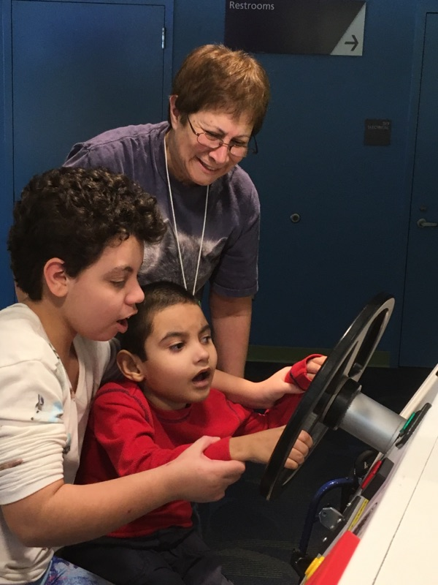 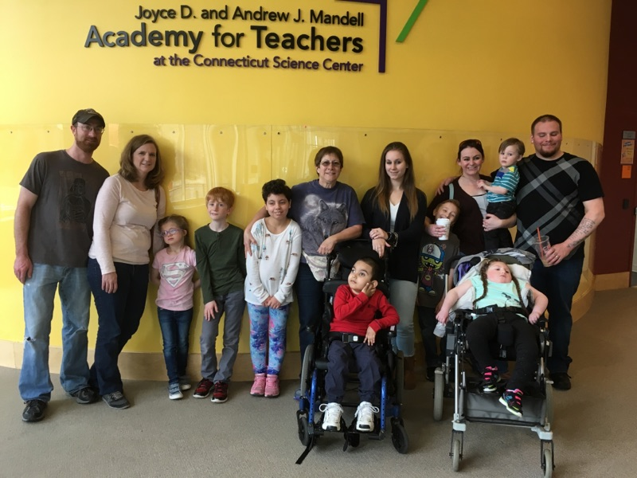

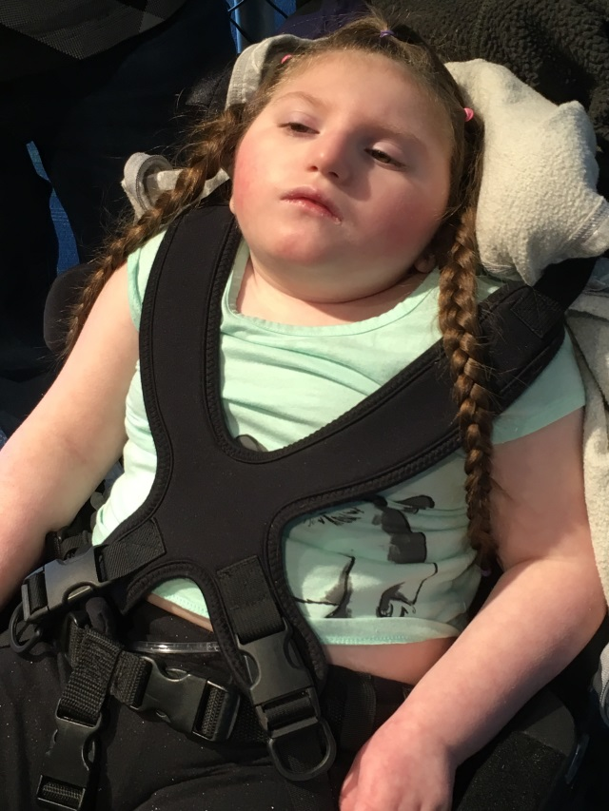 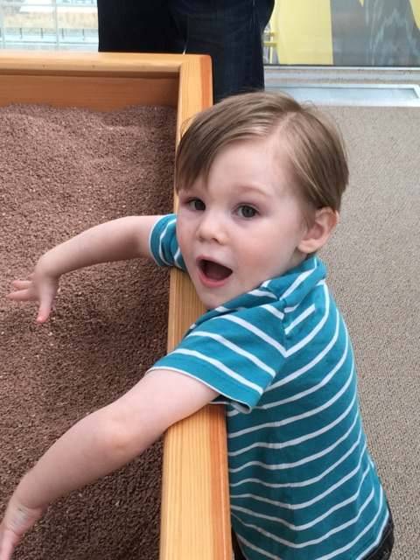

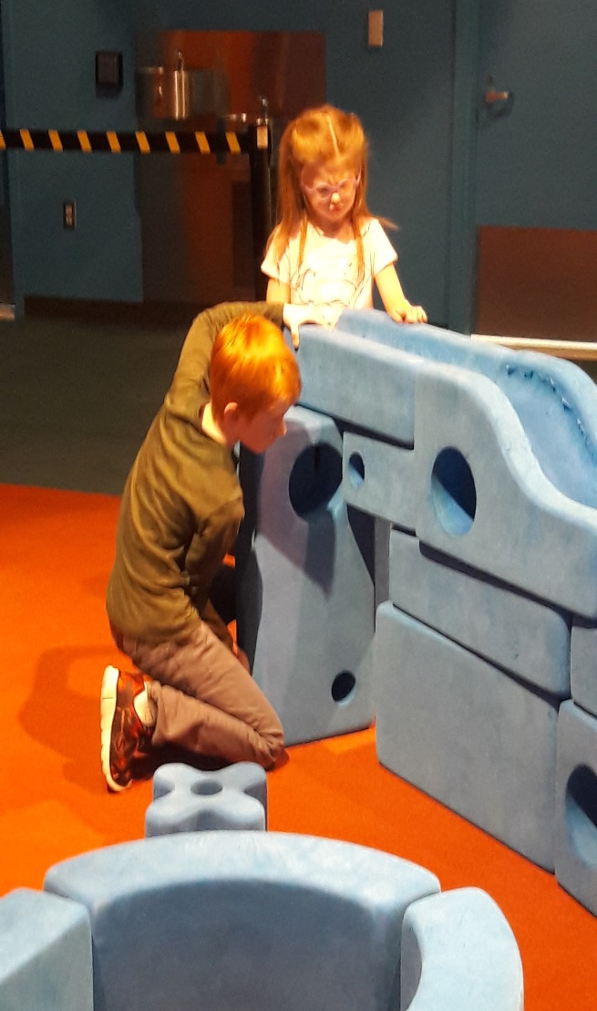 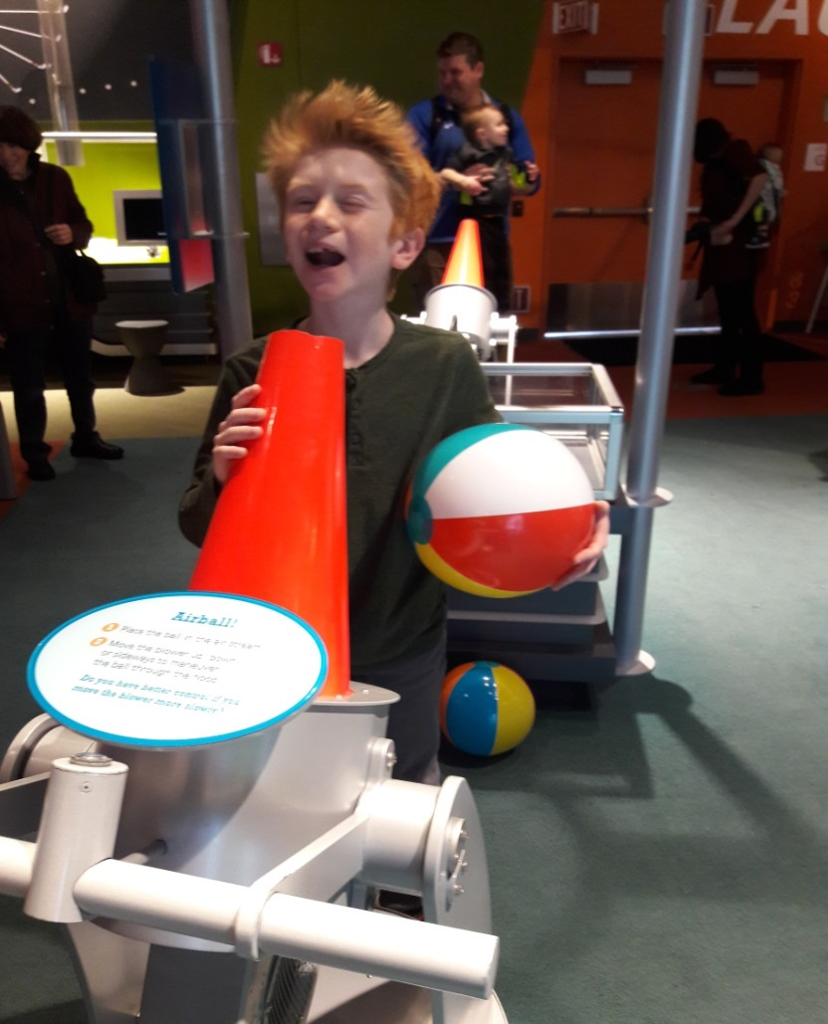

BESB families enjoying the CT Science Center exhibits

Skills for Life Summer Mobility Program

Skills for Life is returning this summer! Tentative dates for the program are 7/31-8/4 in West Haven.

Interested high school students should contact their orientation and mobility instructor for more information.

**********************************************************************************

Save the Date

The Fall Workshop, *“Teaching Students who are Visually Impaired with Additional Disabilities, including Deafblindness”* has been scheduled for the following dates in West Hartford at *no cost to attend*:

Wed 9/27/17-Paraprofessionals

Thurs 9/28/17-Families/Education Teams/Administration

This workshop is an *introduction* to best practice strategies that support meaningful instruction for our students. We discuss Cortical Visual Impairment, Total Blindness, Communication, Calendar Systems, Orientation & Mobility and more. BESB is able to offer this workshop in collaboration with NEC; the New England Consortium for Deafblind Projects. <http://www.nec4db.org/>.

Registration information will be available in the fall.

We look forward to meeting you in the fall!

College Day!

Come join us at Southern Connecticut State University to gather important information about applying to college, disability resources, orientation and mobility instruction and a tour of campus.

Wednesday, May 3, 2017

9:30 AM – 3:00 PM

Age 16 & up

Accepting up to 10 students

Interact with other college-bound students, meet a disability resources coordinator, and learn about college expectations and how to prepare both socially and academically.

For further information, please contact your TVI or

Barry Rita 860-602-4069  barry.rita@ct.gov



Teen Escape Day is Coming!

Have you ever wanted to learn how to use a pottery wheel?

Or build a coil pot?

Here is your chance!

Join us for a day of creative learning and meet new friends!

Wednesday April 26 9:30-2:30 at

Creative Clay Spot

1103 Farmington Avenue, Berlin, CT

For more information please contact Patti Fahle at

[Patricia.fahle@ct.gov](mailto:Patricia.fahle@ct.gov)

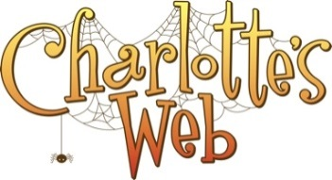

Garde Arts Center

325 State Street, New London, CT

Tuesday, June 6, 2017 9:30am – 1:30pm

The Garde Arts Center in New London, CT will be putting on a live performance of Charlotte's Web and YOU are invited!!

This trip is being offered to BESB students grades K-4. We have 40 seats available, so reserve your seat TODAY!!

Following the live performance, there will be a meet and greet with the actors for the students to be able to touch and see the costumes up close. Weather permitting; we will be walking down to the City Pier to enjoy a picnic lunch.

***LUNCH IS NOT PROVIDED. PLEASE PACK A LUNCH FROM HOME***

Registration is online for this event

<https://www.eventbrite.com/e/charlottes-web-at-the-garde-arts-theatre-tickets-32268812888>

PLEASE REGISTER EACH PERSON ATTENDING THE SHOW INDIVIDUALLY - EVEN ADULTS - SO THAT WE HAVE ENOUGH SPACE FOR EVERYONE!