### [Illustration of a bee flying, "writing" the word, "buzz" as he flies.](https://www.google.com/url?sa=i&rct=j&q=&esrc=s&source=images&cd=&cad=rja&uact=8&ved=0ahUKEwjnzoyE8pjXAhVOySYKHZeED_kQjRwIBw&url=https://www.mybeeline.co/en/p/why-do-bees-buzz-2&psig=AOvVaw0_jAnnCTU5UTUwBbY-K64v&ust=1509471581108461)THE BESB BUZZ….

A Newsletter for Families of Children who are Blind or Visually Impaired

## Volume 19 DORS. Live. Learn. Work. Fall 2017

## Published by the State of Connecticut

## Department of Rehabilitation Services (DORS)

Bureau of Education and Services for the Blind (BESB)

Feature Articles:

Look Who’s New, CT Chapter of NAPVI, *How Visual Impairment* *has* *Changed My Thinking,* VR Parent Survey, CVI Phase III iPad apps, Web Resources for Parents, Making Art & Literacy Accessible,

Recent Field Trips, Upcoming Programs

In an effort to provide you with faster delivery of our newsletter and program flyers, save paper, and contain printing costs, we are now posting an expanded electronic version on our website: [www.ct.gov/besb](http://www.ct.gov/besb).

(Newsletter is also available in Spanish on our website)

If you provide us with your e-mail address, we will send a copy of the newsletter directly to you by e-mail. Please give your preferred e-mail address to your child’s TVI or contact the newsletter’s co-editors, [lisa.pruner@ct.gov or](mailto:lisa.pruner@ct.gov%20or) [tina.gutierrez@ct.gov](mailto:tina.gutierrez@ct.gov)

We welcome your comments and ideas for future newsletter topics.

Look Who’s New! [](http://www.google.com/url?sa=i&rct=j&q=&esrc=s&source=images&cd=&cad=rja&uact=8&ved=0ahUKEwiwuN_AxYnXAhUD4IMKHQ4cDS8QjRwIBw&url=http://classrooms.tacoma.k12.wa.us/tms/byers6/welcome-to-ms-byers-6th-grade-math-class&psig=AOvVaw0-DBZ732CPxjk7poLCd_Or&ust=1508944236711377)

Hello! My name is Michele Zordan and I am thrilled to be a part of the Children’s Services team at BESB! Prior to coming to BESB, I worked as a music/band teacher for almost eight years, grades PreK-8th, in New Haven. I got into the vision field through a colleague who used to work as a transcriptionist. Changing careers has been the most terrifying and rewarding thing I have ever done. I love to teach and have so much fun working with students. I am thankful every day that I get the privilege to work with such amazing children! I live with my amazing family; which includes my first grader son, and my mini schnauzer, Chippy. I love to play the French horn, as well as read, crochet, and sew.

[](http://www.google.com/url?sa=i&rct=j&q=&esrc=s&source=images&cd=&cad=rja&uact=8&ved=0ahUKEwiVyP_lyInXAhUH_IMKHeRmBbwQjRwIBw&url=http://mzayat.com/clipart/happy-retirement-clipart.html&psig=AOvVaw1_9vDjeQaJ2Tj-s8dUUSWC&ust=1508945055290134)

* **Martha Delaney, Preschool Education Consultant, has retired as of January 2017 after more than ten years with BESB and many more as a contractor and with students at Oak Hill School.**
* **Cheryl Brown, School Age Education Consultant, has retired as of June 2017 after 37 years with BESB. In addition to her duties as a TVI, Cheryl served as a Unit Coordinator and as Connecticut coordinator for the UMass Boston TVI training program.**

CT NAPVI Parent Group

A Welcome Message from Shanda Easley, Organizer

Hello, my name is Shanda Easley. My daughter Helena has low vision and did not know anyone else with a visual impairment. I wanted to start a parent group to provide families and students with the chance to network and support each other. Quarterly gatherings, email communication, and activities are facilitated. The group continues to grow and enjoyed the apple picking event held on Oct. 7 in collaboration with NEC, the New England Consortium of Deafblind Projects. <http://www.nec4db.org/>

Questions or Ideas? Shanda can be reached at [NAPVICT@gmail.com](mailto:NAPVICT@gmail.com)

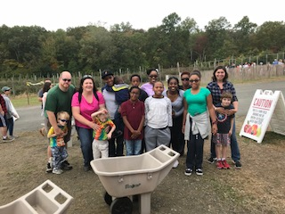

Apple Picking at Bishop’s Orchard

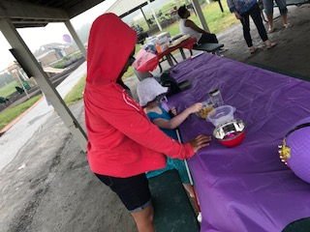

Students enjoying CT NAPVI event

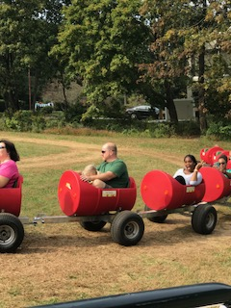 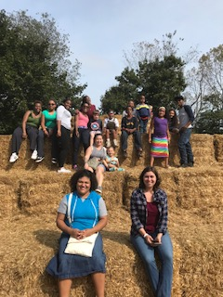

More Photos for NEC/CT NAPVI Apple Picking



GARDE ARTS CENTER ELEMENTARY

FIELD DAY By Beth Borysewicz

By, Beth

On June 6, 15 students in grades K-4 went on an adventure to the Garde Arts Center in New London. The theater gave us the VIP treatment and reserved a space for our group directly in front of the stage.

A banquet length table was provided to set up portable distance viewers for use by students with low vision. These *Visio Books* allowed our students to see the stage, actors, and performance. Students with no vision were able to enjoy the performance through the use of headsets and *audio description.* A BESB TVI narrated the performance via a microphone connected to the headphones. Detailed descriptions of all non-verbal gestures on stage were provided so students did not miss out on any visual cues needed to understand the story line.

The Garde Arts Theatre arranged a meet and greet with the actors following the performance to provide hands-on exploration of costumes and the chance to speak directly with the actors. Both the actors and students enjoyed their time together learning from each other.

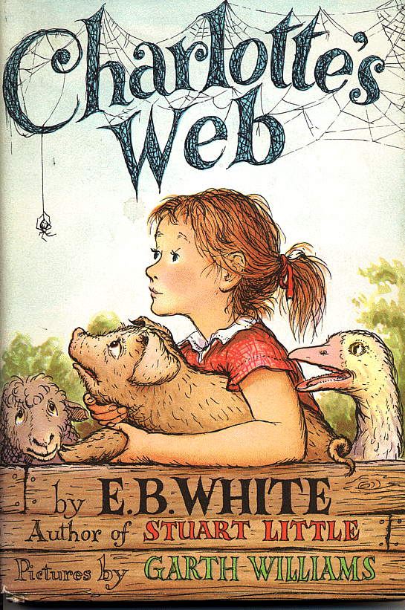

***How Visual Impairment***

***Has Changed the Way I Think***

**Ian is an eleventh grade student at Avon High School. We thank him for sharing his perspective.**

***A lot can be learned from a person by asking them what they see and this extends far beyond the visually impaired. In the early months of 2017 it seemed as though reality itself was slipping away from me as my vision rapidly deteriorated. Fear of this overcame my life. Over time, this mountain range of discomfort was eroded, leaving who I am now to observe and learn from the experience. I am Ian Albreski, I have Leber’s Hereditary Optic Neuropathy and am visually impaired as a result.***

***By going blind I have been forced to explain to the people who I saw every day these new circumstances in my life. I became a novelty to some and was asked many questions, although I want to focus on a question that I have grown quite fond of: “What do you see?” This is rarely a well thought-out question, but it can produce well thought-out answers. There is not an easy answer to this question for someone with my condition. Imagine the most beautiful picture, remove the detail, and blend all the colors in the focal point until the vibrancy of the scene has drifted into periphery.  That is the world as I see it: potentially perfect in every way, existing beyond my reach. But in this response I attempt to avoid any indication that I suffer or have lost. The simple question of what a person sees can contain anything from the literal to a glimpse of a world view. Often times our beliefs show them by what we choose to see and how we choose to see it. I always try to see as much as I physically can. Despite this, being visually impaired, I think it important to see through intellectual means that also stimulate how the world is viewed.***

***Every person sees the world through a lens of their creation, with every bit of life experience changing what it is in front of them. The separation I have had with the seeing world in the past year has not pushed me further from the world as a whole. Visual impairments prompt change, but what you see is not the world. This is because change, on a personal level, is never universal.***

A SURVEY FROM OUR FRIENDS IN THE DORS-BESB

VOCATIONAL REHABILITATION PROGRAM

*For Parents of Children Aged 14-21 Years:*

The *Vocational Rehabilitation Program (VR)* at DORS-BESB is looking to provide the most appropriate transition program options for your child. Completing this survey will help VR to plan more effectively.

*What age is your transition age child? ______________

*Are you currently receiving notifications about VR transition program opportunities? ______________________

*How do you receive information about VR transition programs? _____________________________________

*What types of VR transition programs are you interested in for your child? ___________________________________________________

*Where would you prefer these VR transition programs be held?

*When would you prefer these VR transition program opportunities be scheduled? _________________________________________________

*What may be preventing your transition age child from attending VR transition programs? (Ex: transportation, after-school program commitments, appropriate transition programs currently offered through school) __________________________________________

*How would you prefer to receive notification of VR transition program opportunities? (email or other) Include that information here: ____________________________________________________________

Please call or return this survey to Barry Rita; thank you for your time.

*BARRY RITA, Transition Coordinator*

Tel. #860-602-4069 Fax# 860-602-4020 [**Barry.Rita@ct.gov**](mailto:Barry.Rita@ct.gov)

**iPAD APPS FOR STUDENTS WITH CVI IN PHASE III**

**By Matt Tietjen**

[](https://www.google.com/url?sa=i&rct=j&q=&esrc=s&source=images&cd=&cad=rja&uact=8&ved=0ahUKEwjIopiG9onXAhXm6IMKHSLoBHwQjRwIBw&url=https://itunes.apple.com/us/app/goodnotes-4/id778658393?mt%3D8&psig=AOvVaw1SnTP1B5_2LczZA5BVt1u8&ust=1508957274946621)**Goodnotes: Time Base Tech Limited**

*Take pictures of educational materials, zoom in on details, isolate one problem & write on it.*

[](https://www.google.com/url?sa=i&rct=j&q=&esrc=s&source=images&cd=&cad=rja&uact=8&ved=0ahUKEwji-8PU9onXAhUpzIMKHXPPBkYQjRwIBw&url=https://otswithapps.com/2014/07/01/snaptype-app-for-occupational-therapy-a-tool-for-dysgraphic-students/&psig=AOvVaw0-yXIRSBk6EKD7YYBcNQk5&ust=1508957436241686)**Snaptype: SNAPTYPE, LLC**

*Minimize complexity in worksheets by taking a picture of a worksheet, zooming in on one problem at a time.*

[](https://www.google.com/url?sa=i&rct=j&q=&esrc=s&source=images&cd=&cad=rja&uact=8&ved=0ahUKEwip-oDw9onXAhWCy4MKHYfjB6AQjRwIBw&url=https://itunes.apple.com/us/app/bitsboard-pro-flashcards-educational-games-app/id646240375?mt%3D8&psig=AOvVaw3b4kClrjH1jZICHVWneyAm&ust=1508957487573748)Bitsboard Pro: Innovative Investments Limited

*Make custom flashcard activities, create custom picture touch games.*

[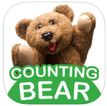](https://itunes.apple.com/us/app/counting-bear-easily-learn-how-to-count/id414967966?mt=8)Counting Bear: Innovative Investments Limited

*Great for math; visually mark each item as it is counted.*

[](https://itunes.apple.com/us/app/pictello/id397858008?mt=8)Pictello: AssistiveWare

*Make custom stories; modify actual children’s books, students help write experience stories.*

[](http://www.voicedream.com/) Voicedream app: Voice Dream LLC

*Read (or listen to) any PDF or word document; adjust font style & size.*

[](https://itunes.apple.com/us/app/you-doodle-draw-on-photos-and-text-editor/id517871755?mt=8)YouDoodle: Digital Ruby, LLC

*Import pictures & highlight salient features (as recommended & taught by Dr. Christine Roman).*

[](https://www.join.me/apps)Join Me: Log MeIn, Inc

*SMARTboard &/or computer presentation can be shared directly with the student’s iPad in order to access distance information.*

CALCULATORS: *Scientific & Graphing calculators can be a challenge due to complexity of array. The following calculator apps incorporate color coding to reduce complexity.*

[](https://itunes.apple.com/us/app/kalkulilo-scientific-calculator/id286091993?mt=8)[****Kalkulilo Scientific Calculator****](https://itunes.apple.com/us/app/kalkulilo-scientific-calculator/id286091993?mt=8): Alexander Clauss

*Uses color coding to help reduce the visual complexity of the keyboard & to group keys by function.*

[](https://itunes.apple.com/us/app/scientific-graphing-calculator-2/id1066347637?mt=8)****Scientific Graphing Calculator:**** William Jockusch

*Each graph on a coordinate plane is a different color & is color-coded to match the equation that goes with it.*

[](https://itunes.apple.com/us/app/calculator/id458535809?ls=1&mt=8)[****Calculator (Infinity Symbol): incpt.Mobis****](https://itunes.apple.com/us/app/calculator/id458535809?ls=1&mt=8)

*This calculator uses color to differentiate symbols from numbers & other parts of the equation.*

Complete article can be found at *Paths to Literacy*: 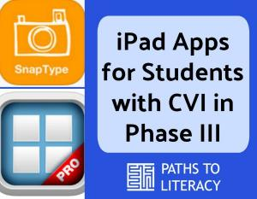<http://pathstoliteracy.org/technology/specific-ipad-apps-students-cvi-phase-iii>. (Reprinted & edited with permission of Author)

[](http://www.google.com/url?sa=i&rct=j&q=&esrc=s&source=images&cd=&cad=rja&uact=8&ved=0ahUKEwjklfXY85jXAhXDPCYKHfB1DloQjRwIBw&url=http://atlantabuzz.com/things-to-do-atlanta-events/pumpkin-painting-party-2/&psig=AOvVaw33IL8wA2vg6cw4Ttg11aj6&ust=1509472001873655) Art Through the Eyes of the Holder

By Patti Fahle & Adrienne Brown [](http://www.google.com/url?sa=i&rct=j&q=&esrc=s&source=images&cd=&cad=rja&uact=8&ved=0ahUKEwjklfXY85jXAhXDPCYKHfB1DloQjRwIBw&url=http://atlantabuzz.com/things-to-do-atlanta-events/pumpkin-painting-party-2/&psig=AOvVaw33IL8wA2vg6cw4Ttg11aj6&ust=1509472001873655)

BESB teachers Patti Fahle and Adrienne Brown teamed up with Bolton Center School’s art teacher, Polly Vouglas, to lead a workshop at the CAEA (Connecticut Art Education Association) conference held on October 19. The workshop was entitled *“Art Through the Eyes of the Holder”* and focused on simple adaptations to make visual art more meaningful for students with blindness or low vision.

The workshop leaders facilitated a hands-on art lesson where participants acted as classroom students. Participants wore low vision simulators or blindfolds which aided their understanding of the art making experience for students with visual impairments.

The art lesson focused on the elements of shape and form, as well as the principle of rhythm. Participants explored the 3 dimensional form of a pumpkin (a sphere) and translated that form into its 2 dimensional equivalent (a circle). The principle of rhythm was explored by feeling and re-creating the repetitious ridges of a pumpkin’s surface. The end result was a 2-d representation of a pumpkin.

Adaptations for low vision participants included bold, high contrast colored materials. Participants who were blindfolded used materials like tactile paper, wiki sticks, pipe cleaners, and other found appropriate objects. Different paper selections reflected the texture of the ridged stem, smooth skin, and rough patches on the pumpkin.

Patti, Adrienne, and Polly continue to enjoy making creative expression more accessible for students with visual impairments!

[](https://www.google.com/url?sa=i&rct=j&q=&esrc=s&source=images&cd=&cad=rja&uact=8&ved=0ahUKEwjPlYrS7YnXAhWM6oMKHbHSDhcQjRwIBw&url=https://www.pinterest.com/pin/212724782371291175/&psig=AOvVaw1xSQz1D9I5z7lSnpYt812k&ust=1508954992379177)

RESOURCES FOR PARENTS: A WEBSITE DIRECTORY

By Jessie Mabry

Both new and veteran parents can benefit from networking, information, and mentorship. The *Spring BESB Buzz* shared a variety of on-line resources. This updated directory includes new websites!

[](http://www.google.com/url?sa=i&rct=j&q=&esrc=s&source=images&cd=&cad=rja&uact=8&ved=0ahUKEwjEoIWuzozXAhUCKyYKHeWHC_YQjRwIBw&url=http://icons.mysitemyway.com/legacy-icon-tags/check-mark/page/14/&psig=AOvVaw0VHD2U-6gSY7oxRx0Bbplx&ust=1509049684046884)National Association of Parents of Children With Visual Impairments: <http://www.napvi.org> *CT Chapter:* [*napvict@gmail.com*](mailto:napvict@gmail.com)

[](http://www.google.com/url?sa=i&rct=j&q=&esrc=s&source=images&cd=&cad=rja&uact=8&ved=0ahUKEwjEoIWuzozXAhUCKyYKHeWHC_YQjRwIBw&url=http://icons.mysitemyway.com/legacy-icon-tags/check-mark/page/14/&psig=AOvVaw0VHD2U-6gSY7oxRx0Bbplx&ust=1509049684046884)New England Consortium for Deafblind Technical Assistance and Training (NEC): <http://www.nec4db.org>

[](http://www.google.com/url?sa=i&rct=j&q=&esrc=s&source=images&cd=&cad=rja&uact=8&ved=0ahUKEwjEoIWuzozXAhUCKyYKHeWHC_YQjRwIBw&url=http://icons.mysitemyway.com/legacy-icon-tags/check-mark/page/14/&psig=AOvVaw0VHD2U-6gSY7oxRx0Bbplx&ust=1509049684046884)Pediatric Cortical Visual Impairment Society (CVI): <http://www.pediatriccvisociety.org>

[](http://www.google.com/url?sa=i&rct=j&q=&esrc=s&source=images&cd=&cad=rja&uact=8&ved=0ahUKEwjEoIWuzozXAhUCKyYKHeWHC_YQjRwIBw&url=http://icons.mysitemyway.com/legacy-icon-tags/check-mark/page/14/&psig=AOvVaw0VHD2U-6gSY7oxRx0Bbplx&ust=1509049684046884)Perkins e-Learning: <http://www.perkinselearning.org>

[](http://www.google.com/url?sa=i&rct=j&q=&esrc=s&source=images&cd=&cad=rja&uact=8&ved=0ahUKEwjEoIWuzozXAhUCKyYKHeWHC_YQjRwIBw&url=http://icons.mysitemyway.com/legacy-icon-tags/check-mark/page/14/&psig=AOvVaw0VHD2U-6gSY7oxRx0Bbplx&ust=1509049684046884)Teaching Students with Visual Impairments: <http://www.teachingvisuallyimpaired.com>

[](http://www.google.com/url?sa=i&rct=j&q=&esrc=s&source=images&cd=&cad=rja&uact=8&ved=0ahUKEwjEoIWuzozXAhUCKyYKHeWHC_YQjRwIBw&url=http://icons.mysitemyway.com/legacy-icon-tags/check-mark/page/14/&psig=AOvVaw0VHD2U-6gSY7oxRx0Bbplx&ust=1509049684046884)Texas School for the Blind and Visually Impaired: <http://www.tsbvi.edu>

[](http://www.google.com/url?sa=i&rct=j&q=&esrc=s&source=images&cd=&cad=rja&uact=8&ved=0ahUKEwjEoIWuzozXAhUCKyYKHeWHC_YQjRwIBw&url=http://icons.mysitemyway.com/legacy-icon-tags/check-mark/page/14/&psig=AOvVaw0VHD2U-6gSY7oxRx0Bbplx&ust=1509049684046884)American Council of the Blind: <http://www.acb.org>

[](http://www.google.com/url?sa=i&rct=j&q=&esrc=s&source=images&cd=&cad=rja&uact=8&ved=0ahUKEwjEoIWuzozXAhUCKyYKHeWHC_YQjRwIBw&url=http://icons.mysitemyway.com/legacy-icon-tags/check-mark/page/14/&psig=AOvVaw0VHD2U-6gSY7oxRx0Bbplx&ust=1509049684046884)National Federation of the Blind(NFB): <http://www.nfb.org>

[](http://www.google.com/url?sa=i&rct=j&q=&esrc=s&source=images&cd=&cad=rja&uact=8&ved=0ahUKEwjEoIWuzozXAhUCKyYKHeWHC_YQjRwIBw&url=http://icons.mysitemyway.com/legacy-icon-tags/check-mark/page/14/&psig=AOvVaw0VHD2U-6gSY7oxRx0Bbplx&ust=1509049684046884)NFB: Topical e-mail lists: <http://nfbnet.org>

[](http://www.google.com/url?sa=i&rct=j&q=&esrc=s&source=images&cd=&cad=rja&uact=8&ved=0ahUKEwjEoIWuzozXAhUCKyYKHeWHC_YQjRwIBw&url=http://icons.mysitemyway.com/legacy-icon-tags/check-mark/page/14/&psig=AOvVaw0VHD2U-6gSY7oxRx0Bbplx&ust=1509049684046884)Independent Living Aids: <http://www.independentliving.com>

[](http://www.google.com/url?sa=i&rct=j&q=&esrc=s&source=images&cd=&cad=rja&uact=8&ved=0ahUKEwjEoIWuzozXAhUCKyYKHeWHC_YQjRwIBw&url=http://icons.mysitemyway.com/legacy-icon-tags/check-mark/page/14/&psig=AOvVaw0VHD2U-6gSY7oxRx0Bbplx&ust=1509049684046884)Maxiaids: <http://www.maxiaids.com>

Fire Safety Grant Awarded

Through the efforts of BESB Education Supervisor, Catherine Summ, and Preschool Education Consultant, Lisa Pruner, DORS-BESB was recently awarded a $3000.00 grant through FM Global Fire Service Programs. Funds from this grant were used to create ten hands-on, ‘fire safety’ themed literacy skills kits for children with visual impairments. These kits were donated to fire safety education programs throughout Connecticut. In addition to the donated kits, a safety day program for students with visual impairments is being planned for the spring.

[](http://www.google.com/url?sa=i&rct=j&q=&esrc=s&source=images&cd=&cad=rja&uact=8&ved=0ahUKEwjviL_r5InXAhXm54MKHV2BDkUQjRwIBw&url=http://www.clker.com/clipart-red-fire-truck-hat-4.html&psig=AOvVaw2ObQCXbpQGlaRsJ4xdfYS3&ust=1508952636548027)

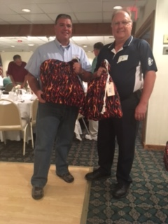

Fire Chiefs Accepting Donated Bags

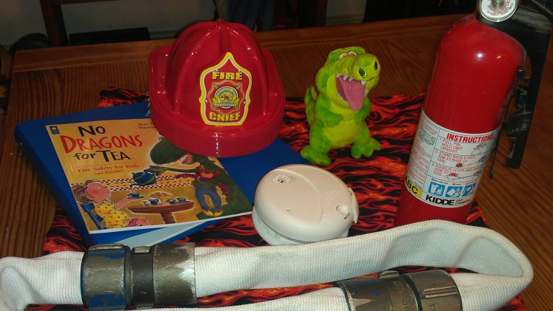

Contents of Fire Safety-Themed

Literacy Skills Kit

Annual Fall In-Service Programs Train

Educators and Families

A grand total of *229* educators and family members participated in one of six days of training provided free of charge by BESB staff in late September and early October.

*102* educators and family members attended two full days of training in September focusing on strategies for working with children with vision impairment and multiple disabilities, including deafblindness.

*27* educators attended training for classroom teachers working with learners of braille, *28* educators attended training for staff working with readers of large print, and *34* educators participated in training for paraprofessionals working with learners of braille.

*38* teachers and therapists participated in one full day of training for those working with preschool children with visual impairments and blindness.

[](https://www.google.com/imgres?imgurl=http://wikiclipart.com/wp-content/uploads/2016/10/0-images-about-snowflakes-on-snowflakes-clip-art.jpg&imgrefurl=http://wikiclipart.com/snowflake-clip-art_4937/&docid=UFi55Up4Xlf8kM&tbnid=h_0hZp0TKQQTjM:&vet=10ahUKEwiH7-Du1InXAhVq1oMKHSFnAS8QMwgyKA0wDQ..i&w=1022&h=295&bih=491&biw=1080&q=line%20of%20snowflakes%20clipart&ved=0ahUKEwiH7-Du1InXAhVq1oMKHSFnAS8QMwgyKA0wDQ&iact=mrc&uact=8)

Making the Sharing of Holiday Traditions

Accessible to All Children

By Tina Gutierrez

Our most loved traditions are the activities and experiences we share with family and friends. As we approach the winter holidays, it is just as much fun to learn about other family traditions as it is to

share your own.

First grader, Athan, laughed and smiled as he actively shared the joy of his traditions with his friends during his class holiday presentation. Athan and his Mom wrote about their family traditions via

object journal pages.

Athan was able to receptively access the tactile object vocabulary words and then press a sound card to expressively share each tradition with friends. A print sentence was included so friends and adults were able to read the scripted language already meaningful to Athan. One journal page reads, “On Christmas Eve…we leave our stockings by the fire place for Santa to fill”. Athan used his hands to read the real stocking on the page and smiled and laughed together with his friends! Another journal page reads, “We have a big cookie decorating party with all my cousins…I have 12 cousins!” Again Athan used his hands to read the cookie cutters written on the journal page and then activated the voice output button.

Object journals are so much fun to write and read with friends and family. Just ask Athan and his Mom all about it; they would love to share with you! Read more about writing object journals at: <http://www.pathstoliteracy.org/blog/school-home-journals>



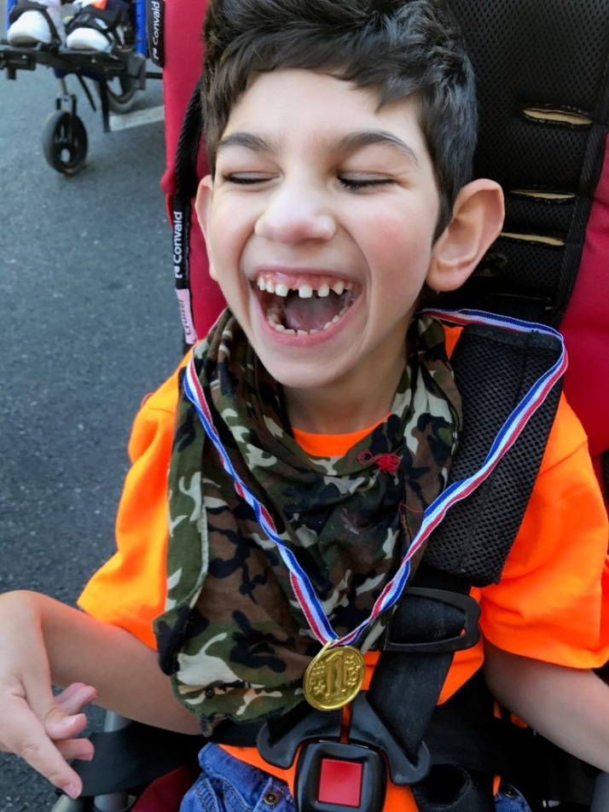 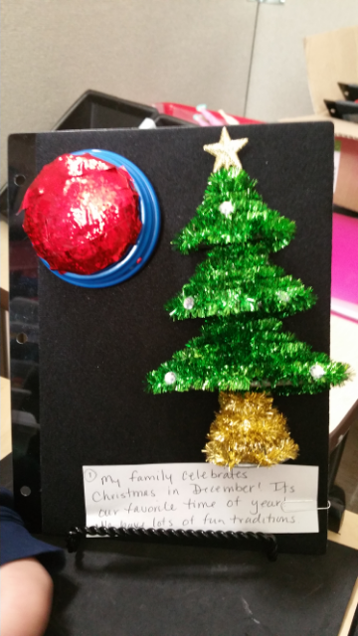

Athan Intro Page of Athan’s Journal

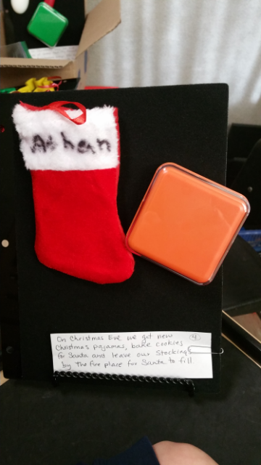

“On Christmas Eve, We Leave Our Stockings by the Fireplace….”

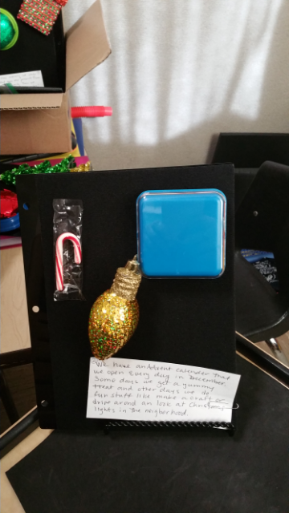 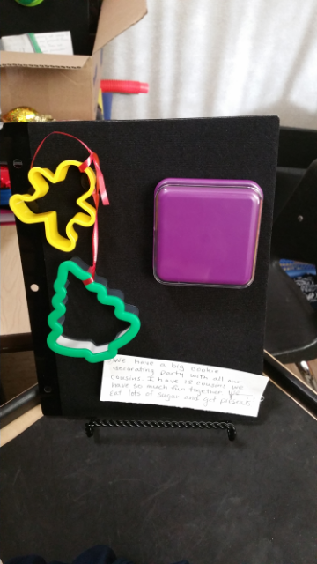

Additional Pages from Athan’s Holiday Traditions Journal

