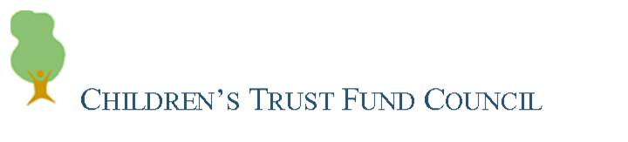
Executive/Special Meeting
Tuesday, October 16, 2012
Agenda

- Welcome

- Review Draft Strategic Plan for Council

- Recommendation to Expand Council Role

- Update:

  - Hiring Development - Director/Community Consultant
  - Meeting with Commissioner

- Focus on Council Operations

- Next Steps

